Name: Muhammad Sherjeel Akhtar

Roll No: 20P-0101

Subject: Technical Business Writing

Assignment No: 4

Submitted To Respected Maam: Noreen Shah



Industries As A Percentage Of Brazil’s Economy:
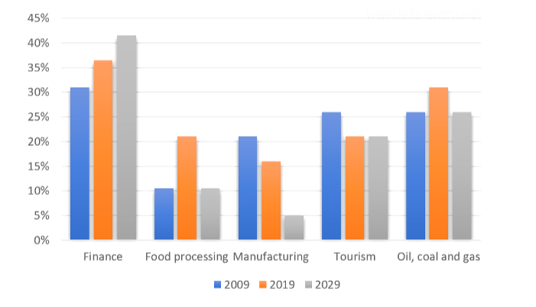
The bar chart shows the actual and projected share of the economy of Brazil held by the five key business sectors for the years 2009, 2019 and 2029.
Starting off with the given figures, the sectors that saw growth between 2009 and 2019 are Finance, Fossil Fuels and Food Processing with rises of around 5 percent for the two former and around 10% for the latter. However, both Tourism and Manufacturing saw falls of around 5% for that period.
Turning next to the projected figures for 2029, only the Finance sector is predicted to see a continued growth in 2029, again by 5%. Of the remaining sectors, tourism stays at 2019 levels with around 21% and both Food Processing and Oil, Coal and Gas return to 2009 levels (11 and 26% respectively). Meanwhile, Manufacturing sees a further drop in its share, falling by a further 10 percent to around 5 percent.
Overall, for the period covered, the Finance sector stands out in terms of having the largest share of brazil’s economy and its share shows continued growth. The big loser is manufacturing, which starts as the joint smallest sector and sees both real and projected falls.

